**DEPARTMENT OF**

**COMPUTER SCIENCE AND ENGINEERING,**

BHILAI INSTITUTE OF TECHNOLOGY (DURG) CHHATTISGARH (INDIA)

“MASH: Transport Booking”

A project submitted to

**Bhilai Institute of Technology,**

**Durg (C.G.)**

*in partial fulfillment for the award of the degree*

*of*

## Bachelor of Technology

## (Computer Science and Engineering)

by

**Mohit Khapekar**

B.Tech Scholar

BIT Durg, Chhattisgarh, India

[aezakmi7974@gmail.com](mailto:aezakmi7974@gmail.com)

**Mohammad Amaan Jahangir**

B.Tech Scholar

BIT Durg, Chhattisgarh, India

[mdamaan135@gmail.com](mailto:mdamaan135@gmail.com)

**Mohammad Saad Siddiqui**

B.Tech Scholar

BIT Durg, Chhattisgarh, India

[mohammadsaadsiddiqui90@gmail.com](mailto:mohammadsaadsiddiqui90@gmail.com)

**Harsh Dewangan**

B.Tech Scholar

BIT Durg, Chhattisgarh, India

[harsh101dewangan@gmail.com](mailto:harsh101dewangan@gmail.com)

**Under the Guidance of**

**Mrs. Monika Verma**

Assistant Professor

BIT Durg, Chhattisgarh, India

[monika.verma@bitdurg.ac.in](mailto:shekhar@gmail.com)

# DECLARATION BY THE CANDIDATE(s)

**We (***the undersigned)* solemnly declare that the report of the project work entitled “**MASH: Transport Booking”**, is based on our own work carried out during the course of our study under the supervision of **Mrs. Monika Verma**.

We assert that the statements made and conclusions drawn are an outcome of the project work. We further declare that to the best of our knowledge and belief that the report does not contain any part of any work which has been submitted for the award of any other degree/diploma/certificate in this University/ any other University of India or any other country.



**CERTIFICATE**

This is to certify that the report of the project entitled “**MASH: Transport Booking”** is an outcome of project work carried out by **Mohit Khapekar**, **Mohammad Amaan Jahangir, Mohammad Saad Siddiqui, Harsh Dewangan of Dept-CSE , Sem-IIIrd,** under my guidance and supervision for the award of Degree of Bachelor Of Technology in Computer Science and Engineering of Bhilai Institute of Technology, Durg (C.G), India.

To the best of my knowledge and belief the report

1. Embodies the work of the candidates themselves.
2. Has duly been completed.
3. Fulfills the requirement of the Ordinance relating to the B.Tech. degree of the College.
4. Is up to the desired standard for the purpose of which it is submitted.



The project work as mentioned above is hereby recommended and forwarded for examination and evaluation.



# CERTIFICATE BY THE EXAMINERS

This is to certify that the project work entitled **-**

“**MASH: Transport Booking”**

carried out by

| **S. No.** | **University Roll No.** | **Enrollment no.** | **Name** |
| --- | --- | --- | --- |
| 1. | 300102220553 | CB4284 | MOHIT KHAPEKAR |
| 2. | 300102221097 | CB4291 | MOHAMMAD AMAAN JAHANGIR |
| 3. | 300102221029 | CA6468 | MOHAMMAD SAAD SIDDIQUI |
| 4. | 300102221081 | CB4275 | HARSH DEWANGAN |

**from Department of Computer Science And Engineering of 3rd Semester** has been examined by the undersigned as a part of the examination for the award of Bachelor of Technology degree in Computer Science and Engineering of Bhilai Institute of Technology, Durg (C.G), India.



## **ACKNOWLEDGEMENT**

We have great pleasure in the submission of this project report entitled **“MASH: Transport Booking”** in partial fulfillment of the degree of Bachelor of Engineering (CSE).

We would like to extend our sincerest gratefulness towards **Dr. Mohan Kumar Gupta**, *Principal, Bhilai Institute Of Technology, Durg (C.G.),* and our Head of the Department **Dr. (Mrs). Sunita Soni,** *Department of Computer Science & Engineering* for their encouragement and cordial support.

We would like to express our heartiest gratitude to the Project-In-Charge **Mrs. Monika Verma** for her precious effort and recommendations for our project, without which this project might not have been a success today.

Acknowledgement is due to our parents, family members, friends, and all those persons who have helped us directly or indirectly in the successful completion of the project work.

Any accomplishment requires the efforts of several people, and this work is no different. While submitting this Project report, I take this opportunity to thank those directly or indirectly related to the Project work.

| **S. No.** | **University Roll No.** | **Enrollment no.** | **Name** |
| --- | --- | --- | --- |
| 1. | 300102220553 | CB4284 | MOHIT KHAPEKAR |
| 2. | 300102221097 | CB4291 | MOHAMMAD AMAAN JAHANGIR |
| 3. | 300102221029 | CA6468 | MOHAMMAD SAAD SIDDIQUI |
| 4. | 300102221081 | CB4275 | HARSH DEWANGAN |

## ABSTRACT

India is a vast country with the majority of its cities and towns connected through roads. Road transportation contributes to 86% share of the freight transport of the country with trucking companies dominating the entire space. With a growing economy and demands rising, the quality of service of the trucking company remains poor. The major reasons are unorganized practice and lack of transparency. Moreover, limited access for customers to reach out to truckers to transport their goods.

This report aims to create a platform for customers and truckers to realize their needs with the help of a mobile application. Customers can search for truckers nearest to their location based on their needs. In addition, customers can also post their transport requirements which can be viewed by truckers. Truckers have options to update their travel plan well in advance making sure they run on full capacity. The application captures customers’ ratings for truckers thus building truckers’ credibility and in turn improving the quality of service. The platform provides a transparent mode of communication between customers and truckers on finalizing prices and eliminating middlemen, who in reality would draw commissions. The scope of the application can be extended to advertisement feeds, deals, and truck sales as a revenue generation model to bear its operational cost.

**Hardware Interface Software Interface Processor:**

Intel core i3 1.90 GHz processor. Front End: React Native & Expo

Memory: 4 GB. Back End: React Native & Javascript

Disk Space: 1 TB. Operating System: Windows 11(64 bit) & MacOS Ventura

## TABLE OF CONTENTS

| ***S. No.*** | ***Particulars*** | ***Page no.*** |
| --- | --- | --- |
|  | Introduction   1. Objective 2. Project Description |  |
|
|  | System Study   1. Existing and proposed system 2. Feasibility Study 3. Tools and Technologies used 4. Hardware and Software Requirements |  |
|
|  | Software Requirements Specification   1. Users 2. Functional Requirements 3. Non-functional Requirements |  |
| **4.** | System Analysis and Design   1. System Perspective 2. Database Design Model |  |
| **5.** | User App   1. User Login 2. User Dashboard 3. Admin Login 4. Content Page |  |
| **6.** | Future Enhancements |  |
| **7.** | Conclusion |  |
| **8.** | Bibliography |  |

1. **INTRODUCTION**

The structure of the Indian trucking industry is a complex network. Customers move their goods entirely to third-party players. The core actors who serve the customers are trucking companies, brokers/agents, and truck owners. Trucking companies are the primary players handling customers’ orders. They are responsible for loading the goods at the source and unloading the goods at the destination. They regulate market prices and allocate goods on tender-based bids to truckers.

Brokers/Agents are intermediates for customers and trucking companies or trucking companies and truck owners. They play an important role in the business continuity of the trucking industry.

Truck owners are ground workforce members who move goods from source to destination. They either own a fleet of trucks or a single truck, primarily acting as truck drivers. They target demand-specific destinations and agree upon a common shipping price with the trucking companies.

The industry is a contingent network where all stakeholders are reliant on each other irrespective of the percentage of contribution to the logistic workflow. The customers have very little option to contact truck drivers directly, portraying the trucking industry as an inefficient service-oriented, and unorganized industry.

Since the industry is dominated by trucking companies, the scope for technology advancements does not exercise down to trucker owners. Trucking companies use technology for self-benefit and to mask truck owners from customers.

The objective of this thesis is to offer a cognitive approach for a more transparent logistic network beneficial to customers and truck owners. The application will be user-friendly such that customers can contact truck drivers and vice versa in a couple of steps.

#### Objective:

This project aims to provide access to different vehicles for Transportation of goods.

* 1. **Project Description:**

**“MASH: Transport Booking”** is a Transportation Based mobile application. Mobile App is divided into Four modules.

* The Idea behind our project
* UI Design
* Authentication
* Database Management

#### SYSTEM STUDY :

**2.1 Existing and Proposed System :**

The Indian trucking industry is an infancy in the use of technology. The prime factors are incorporation of technology, increased shipping cost and poor skill levels. In- spite of such challenges, the industry is focused on incorporating low rate technology adoption systems, which is a promising sign.

Recently, the Indian trucking industry has seen many startup ideas such as Porter, Blowhorn, Shippr, LOTrucks and Cargoji, which bridge the gap between customer and the trucking industry. Their main focus is customer centric, thereby formulating their ideas to mobile applications which can be readily available to customers. Having said that, mobile applications are user friendly and help improve the quality of service.

Despite gaining traction among customers, these startups do not address the concerns of truck owners. They operate as a small scale trucking company operating with their own fleet of drivers and mask truck owners from customers. Tying up with truck owners to operate full time, requires the trucks to be occupied, always incurring huge operational costs. As a result, customers indirectly pay a higher shipping price when availing such services.

And **MASH: Transport Booking**  is one of the proposed solutions.

**2.2 Advantages of “MASH Transport Booking” :**

* **Quality of Service:** Now that truck owners are the sole benefactors of the shipping cost, truckers can guarantee better well-maintained trucks.
* **Time Efficient*:*** Saves users’ time.
* **Better logistic management:** Truck owners ranging from a few fleets of trucks to large can effectively manage their trucks with no extra cost.
* **Social benefits:** Better quality of service reduces shipping delays helping quality of service of other industries who are dependent on the shipped goods.
* **Economic Benefits:** Elimination of middlemen reduces shipping cost benefiting customers as well as truck owners to agree upon a reasonable shipping cost.
* **Customer Interaction :** Provide a transparent logistic forum for customers to interact with truck owners

#### 2.3 Feasibility Study

The feasibility study mainly concentrates on the below three mentioned areas. Among these Economic Feasibility Study is the most important part of the feasibility analysis and Legal Feasibility Study is less considered feasibility analysis.

* **Technical Feasibility–**

In Technical Feasibility current resources both hardware software along with required technology are analyzed/assessed to develop projects. This technical feasibility study gives report whether there exists correct required resources and technologies which will be used for project development. Along with this, the feasibility study also analyzes technical skills and capabilities of the technical team, whether existing technology can be used or not, maintenance and up-gradation is easy or not for chosen technology etc.

* **Operational Feasibility –**

In Operational Feasibility the degree of providing service to requirements is analyzed along with how easy the product will be to operate and maintain after deployment. Along with these other operational scopes are determining usability of the product, determining suggested solutions by the software development team is acceptable or not etc.

* **Economic Feasibility –**

In the Economic Feasibility study the cost and benefit of the project is analyzed. Means under this feasibility study a detailed analysis is carried out of what will be the cost of the project for development which includes all required cost for final development like hardware and software resource required, design and development cost and operational cost and so on. After that it is analyzed whether the project will be beneficial in terms of finance for the organization or not.

**2.4 Tools and Technologies Use :**

#### Programming Languages Used for Development:

* **React Native :** React Native is a JavaScript framework for writing real, natively rendering mobile applications for iOS and Android. It’s based on React, Facebook’s JavaScript library for building user interfaces, but instead of targeting the browser, it targets mobile platforms. In other words: web developers can now write mobile applications that look and feel truly “native,” all from the comfort of a JavaScript library that we already know and love. Plus, because most of the code you write can be shared between platforms, React Native makes it easy to simultaneously develop for both Android and iOS.
* **Tailwind CSS :** There are many CSS frameworks but people always choose the fast and easy framework to learn and use in the project. Tailwind has come with inbuilt a lot of features and styles for users to choose from and is also used to reduce the tendency of writing CSS code and create a beautiful custom UI. It will help you to overcome the complicated task. Tailwind CSS creates small utilities with a defined set of options enabling easy integration of existing classes directly into the HTML code.
* **Redux :** Redux is an [open-source](https://en.wikipedia.org/wiki/Open-source_software) [JavaScript library](https://en.wikipedia.org/wiki/JavaScript_library) for managing and centralizing application [state](https://en.wikipedia.org/wiki/State_(computer_science)). It is most commonly used with libraries such as [React](https://en.wikipedia.org/wiki/React_(web_framework)) or [Angular](https://en.wikipedia.org/wiki/Angular_(web_framework)) for building [user interfaces](https://en.wikipedia.org/wiki/User_interface). Similar to (and inspired by) Facebook's [Flux architecture](https://en.wikipedia.org/wiki/React_(JavaScript_library)#Unidirectional_data_flow), it was created by Dan Abramov and Andrew Clark. Since mid-2016, the primary maintainers are Mark Erikson and Tim Dorr.
* **Expo :**  Expo is a set of tools and services built around React Native and, while it has many [features](https://docs.expo.dev/), the most relevant feature for us right now is that it can get you writing a React Native app within minutes. You will only need a recent version of Node.js and a phone or emulator. If you'd like to try out React Native directly in your web browser before installing any tools, you can try out [Snack](https://snack.expo.dev/).

#### Tools and Libraries:

* **Visual Studio Code:** Visual Studio Code, also commonly referred to as VS Code, is a [source-code editor](https://en.wikipedia.org/wiki/Source-code_editor) made by [Microsoft](https://en.wikipedia.org/wiki/Microsoft) with the [Electron Framework](https://en.wikipedia.org/wiki/Electron_(software_framework)), for [Windows](https://en.wikipedia.org/wiki/Windows), [Linux](https://en.wikipedia.org/wiki/Linux) and [macOS](https://en.wikipedia.org/wiki/MacOS). Features include support for [debugging](https://en.wikipedia.org/wiki/Debugging), [syntax highlighting](https://en.wikipedia.org/wiki/Syntax_highlighting), [intelligent code completion](https://en.wikipedia.org/wiki/Intelligent_code_completion), [snippets](https://en.wikipedia.org/wiki/Snippet_(programming)), [code refactoring](https://en.wikipedia.org/wiki/Code_refactoring), and embedded [Git](https://en.wikipedia.org/wiki/Git). Users can change the [theme](https://en.wikipedia.org/wiki/Theme_(computing)), [keyboard shortcuts](https://en.wikipedia.org/wiki/Keyboard_shortcut), preferences, and install [extensions](https://en.wikipedia.org/wiki/Plug-in_(computing)) that add additional functionality.
* **Figma for UX/UI:** Figma is a [collaborative](https://en.wikipedia.org/wiki/Collaborative_software) [web application](https://en.wikipedia.org/wiki/Web_application) for [interface design](https://en.wikipedia.org/wiki/Interface_design), with additional offline features enabled by desktop applications for [macOS](https://en.wikipedia.org/wiki/MacOS) and [Windows](https://en.wikipedia.org/wiki/Microsoft_Windows). The feature set of Figma focuses on [user interface](https://en.wikipedia.org/wiki/User_interface_design) and [user experience](https://en.wikipedia.org/wiki/User_experience_design) design, with an emphasis on real-time collaboration, Utilizing a variety of [vector graphics editors](https://en.wikipedia.org/wiki/Vector_graphics_editor) and [prototyping](https://en.wikipedia.org/wiki/Software_prototyping) tools. The Figma mobile app for [Android](https://en.wikipedia.org/wiki/Android_(operating_system)) and [iOS](https://en.wikipedia.org/wiki/IOS) allows viewing and interacting with Figma prototypes in real-time on mobile and tablet devices.
* **Firebase Fire Store Database & Authentication:** Firebase is a platform developed by Google for creating mobile and web applications. It was originally an independent company founded in 2011. In 2014, Google acquired the platform and it is now their flagship offering for app development.

#### Hardware and Software Requirements

* **Software Interface:**

The application should support all major app browsers that will make it convenient for the user to access our system with ease. The back- end i.e., the database services will be used to a great extent and hence it will be quite efficiently designed.

* **Hardware Interface:**

The hardware requirement at the user end is really simple and the website can also run on the hardware that can run a basic simple browser, although the hardware should be good enough during peak times for the app servers.

For the mobile application the hardware is any mobile device with Android Operating System. The application, the mobile device must have minimum free storage of 10MB, for good syncing, internet data rate of minimum 0.7mbps.

#### Software Requirements Specification

* 1. **Users**
     1. **Customer: User Will Login Through the Login Page.**

#### Functional Requirements

The features of the application will be:

* + - * It will store all data in a single centralized database (Firebase). The database will contain the following information:

1. Email Id

2. User’s Password

3.The Type of Transport User Booked

* + - * The app will provide Transport details and the prices for the distance Travelled.
      * All the information including Vehicle Type (car or truck), will also be displayed on the site.
      * Each user will have to sign up and then login with an email and password to access his/her account on the site.

#### Non-Functional Requirements

**Performance Requirements:**

The application should be able to operate on all major web-browsers with all of its fundamental functions. It should not slow-down the system even at peak hours without affecting the quality of service of the system.

**Safety & Security Requirements:**

* The server on which the **MASH: Transport Booking Application** has its own security and authentication to prevent unauthorized write/delete access.
* The system should provide a secure login to the users by using advanced secure login algorithms and provide access only to the authorized users as security is the key requirement of this system.
* The Email ID and the password should not be shared with anyone (students/faculty/or anyone else).

#### SYSTEM ANALYSIS AND DESIGN:

* 1. **System Perspective: -**

A system is something formed of parts, each of which interacts with the other parts to achieve some common purpose. In the case of the MASH: Transport Booking App, the modules work individually to support the Driver and help them get better jobs and more income.

It is an example of an online vehicle booking application which will help truckers to attain better jobs and increase their as well as reducing the shipping costs. This app is developed with the aim to increase the income of truckers while also providing their customers with more satisfaction.

The system will provide the following functionality to the system user:

* + 1. Allow users to access Transport information in the app itself.
    2. Allow users to get registered as Customers.
    3. Allow users to view several kinds of transport of different vehicles.
    4. Allow users to access the Rider.

***Database design model :***

***Stage 1***: Planning and Requirement Analysis:

Requirement analysis is the most important and fundamental stage in SDLC. It was performed by the members of the team with inputs from the customer, market surveys and the collected information was then used to plan the basic project approach and to conduct product feasibility study in the economical, operational and technical areas.

Planning for the quality assurance requirements and identification of the risks associated with the project was also done in the planning stage. The outcome of the technical feasibility study is to define the various technical approaches that can be followed to implement the project successfully with minimum risks.

***Stage 2***: Defining Requirements:

Once the requirement analysis was done the next step is to clearly define and document the product requirements. This is done through an SRS (Software Requirement Specification) document which consists of all the product requirements to be designed and developed during the project life cycle.

***Stage 3***: Designing the Product Architecture:

SRS is the reference for product architects to come out with the best architecture for the product to be developed. Based on the requirements specified in SRS, usually more than one design approach for the product architecture was proposed and documented in a DDS - Design Document Specification.

This DDS was then again reviewed by the team and based on various parameters as risk assessment, product robustness, design modularity, budget and time constraints, the best design approach was selected for the product.

A design approach clearly defines all the architectural modules of the product along with its communication and data flow representation with the external and third party modules (if any). The internal design of all the modules of the proposed architecture was clearly defined with the minutest of the details in DDS.

***Stage 4***: Building or Developing the Product:

In this stage of SDLC the actual development started and the product was built. The programming code is generated as per DDS during this stage. If the design is performed in a detailed and organized manner, code generation can be accomplished without much hassle.

Developers must follow the coding guidelines defined by their organization and programming tools like compilers, interpreters, debuggers, etc. are used to generate the code. Different high level programming languages such as C, C++, Pascal, Java and are used for coding. The programming language is chosen with respect to the type of software being developed.

***Stage 5***: Testing the Product:

This stage is usually a subset of all the stages as in the modern SDLC models, the testing activities are mostly involved in all the stages of SDLC. However, this stage refers to the testing only stage of the product where product defects are reported, tracked, fixed and retested, until the product reaches the quality standards defined in the SRS. Black Box testing was done in our product by examining the functionality of an application without peering into its internal structures or workings.

**Stage 6**: Deployment in the Market and Maintenance:

Once the product is tested and ready to be deployed it is released formally in the appropriate market

#### 5. USER APP:

#### 

1. **User Login:**

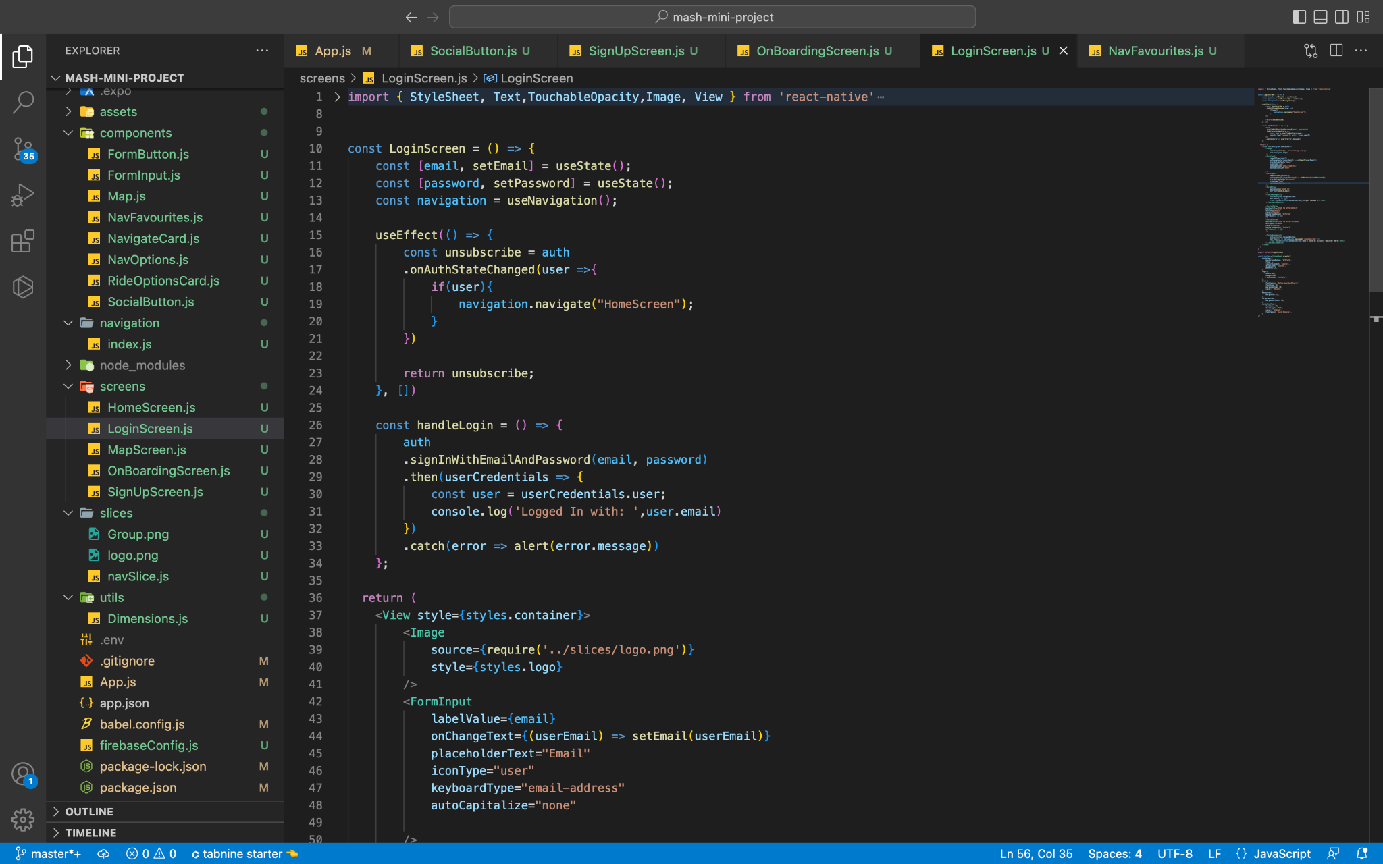

The application's User Login screen allows users to access their accounts by entering their email addresses and passwords. This page opens just after the user enters the app by clicking “SIGN IN”.

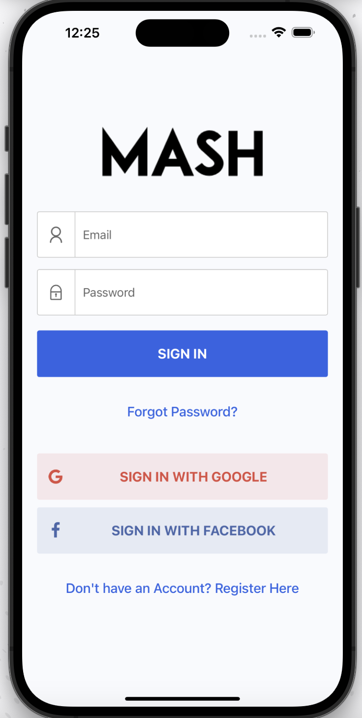

1. **User Dashboard:**

The Dashboard component is the main window that opens the app. As the app opens, the Job names are displayed which further opens up to the content part of the app where the user will find the events

#### 

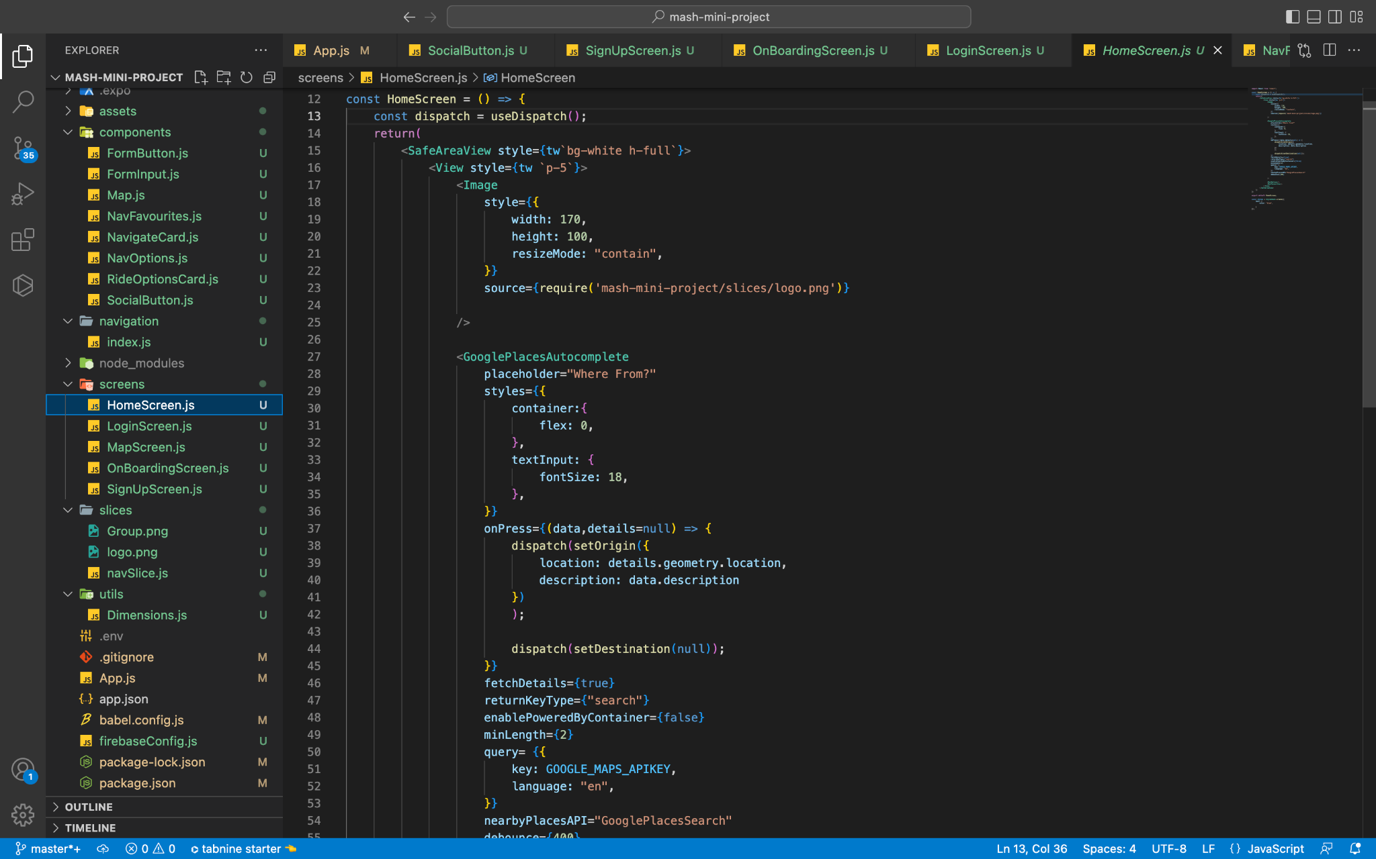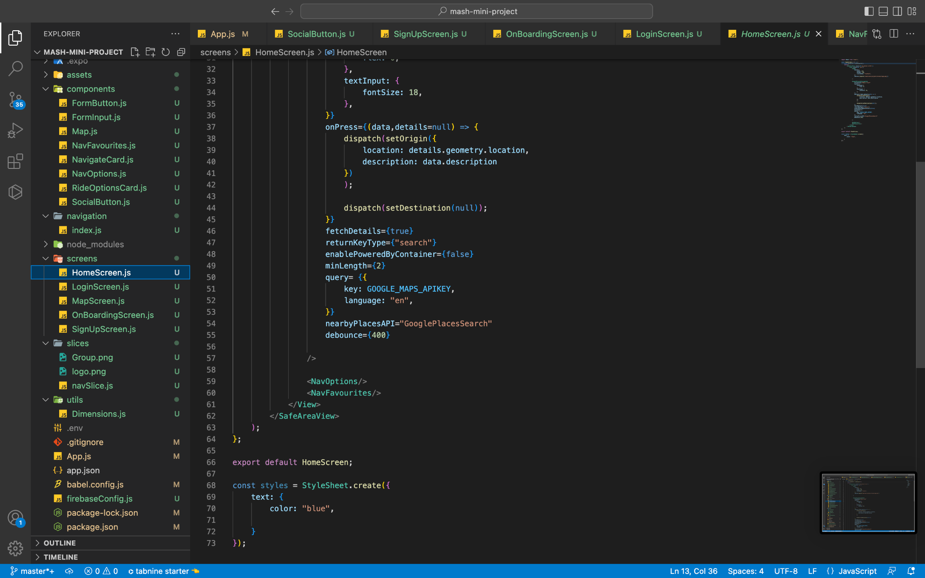

Dashboard give tabs to the various Jobs provided by the app. Under this module, for navigation- Search Bar is used. The Search bar allows you to search the Jobs available near you. You can simply click on the Search bar and type your current location to search for jobs.

1. **Map Screen:**

The map screen show the map of the whole city you are in. You can also set your default Home and Work address saved. You can also put address on the Search bar and look for various jobs available near you.

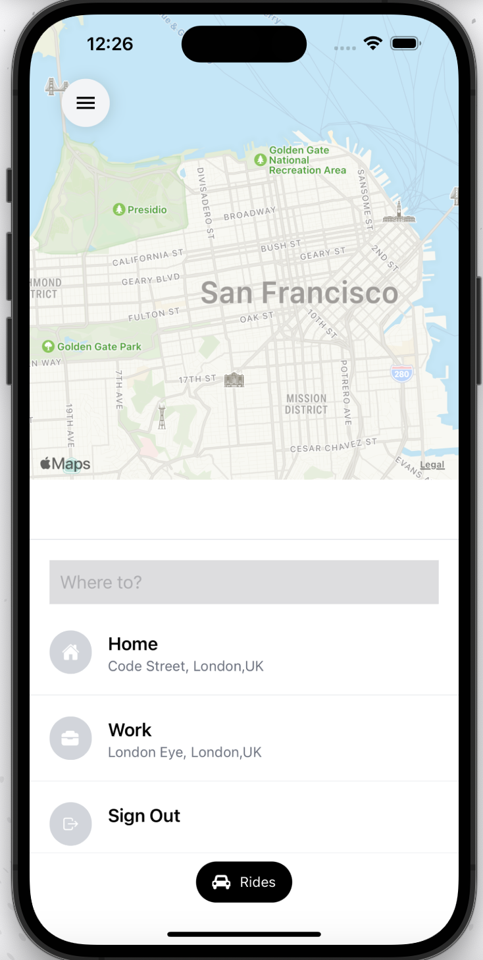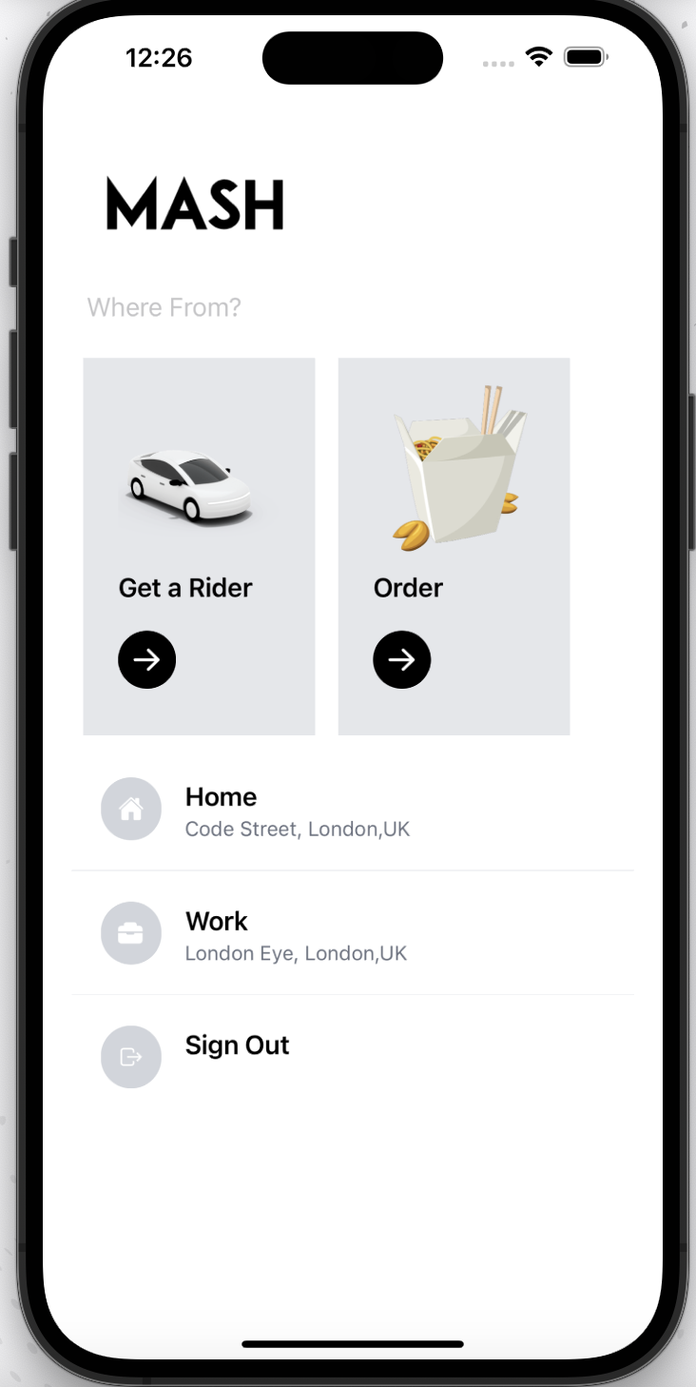



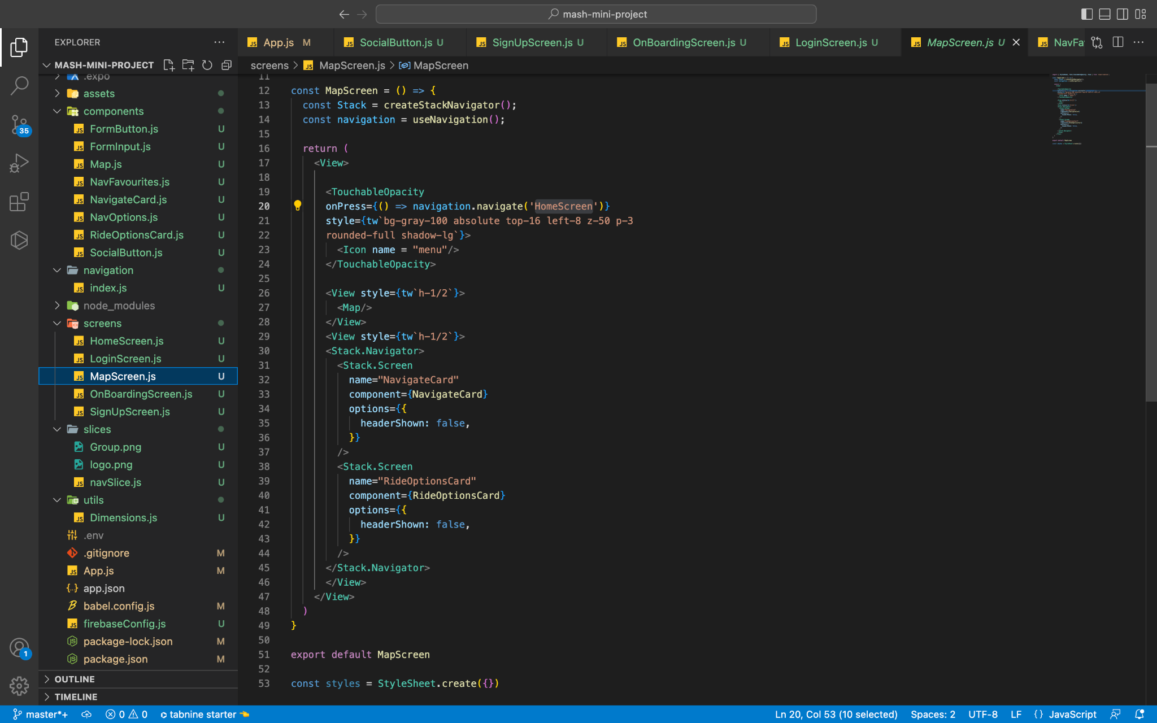

1. **Main App Folder:**

This controls all the main files of the application in addition to with it controls all the data. Without this folder we won’t be able to use the application.

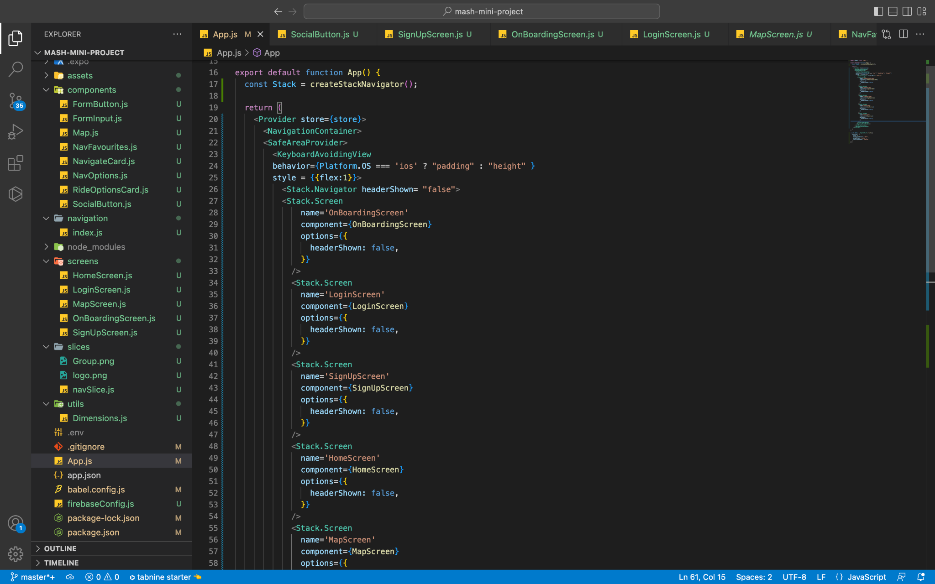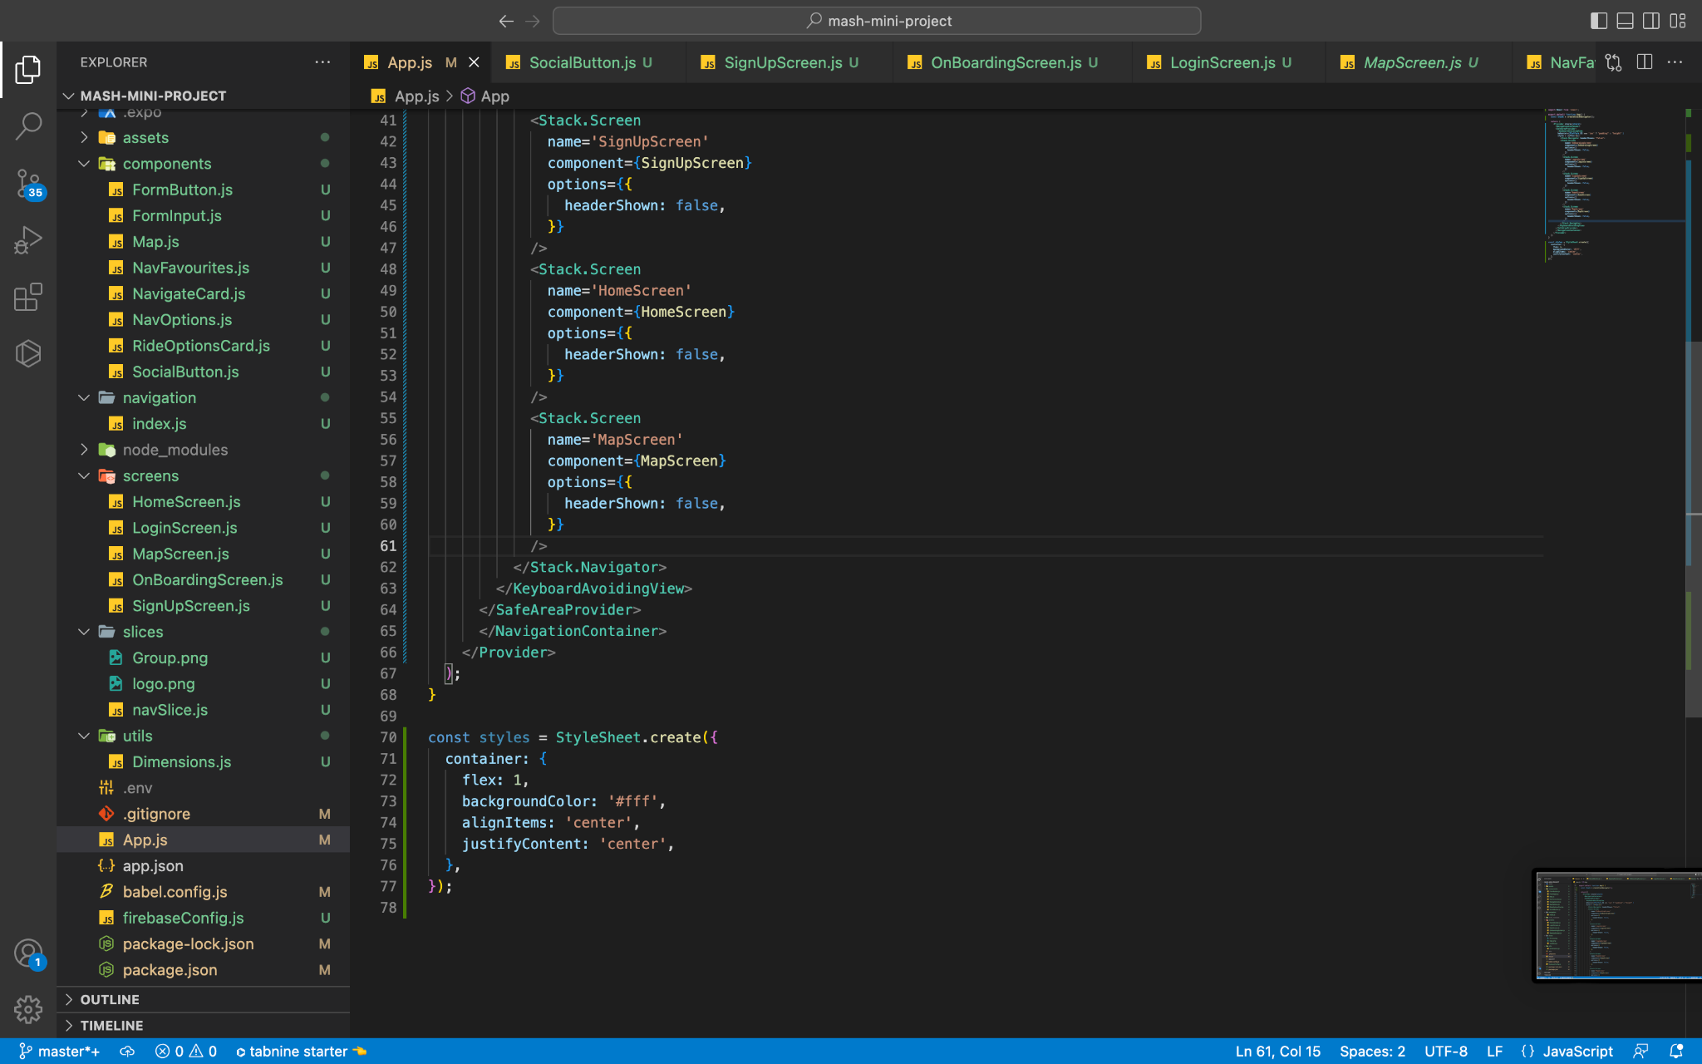

1. **FireBase:**

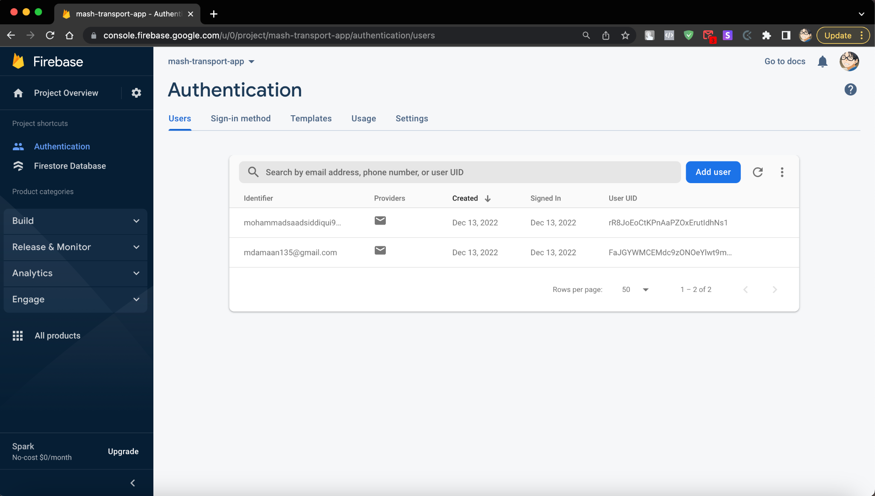

**Firebase** is a set of hosting services for any type of application (Android, iOS, Javascript, Node.js, Java, Unity, PHP, C++ ...). It offers NoSQL and real-time hosting of databases, content, social authentication (Google, Facebook, Twitter and Github), and notifications, or services, such as a real-time communication server.

#### 

#### 6 FUTURE ENHANCEMENTS:

This section highlights future work planned with regard to the proposed thesis idea.

1. Self-sustained revenue model:
   1. In the long run, with more truckers and customers utilizing the mobile application, will require larger databases, efficient algorithms to satisfy the users’ needs. All necessary infrastructure demands investment cost. The most innovative approach would be customizing the mobile application to produce a revenue generation model. In-app advertisements, truck classifieds can be thought of to generate revenue for the application.
2. Real Time Truck Tracking:
   1. The current application does not house a real time truck tracking feature due to inadequate mobile internet connectivity across India. The application depends on mobile internet to determine the user’s location. Installing native
   2. GPS on trucks can help track shipment precisely which might also incur cost.
3. Enhanced User Interface:
   1. Personalized enhancements like storing user’s previous source and destination searches, adding favorite routes, changing form based shipment creation to graphical based shipment creation, would enhance user experience. This will also increase the application’s performance.
4. Data Analytics:
   1. The application’s data can provide a perfect platform to study shipment habits of customers, understand and respond to geographical demands. The outcome of data analytics can be formulated as recommendations to truckers that helps them execute better business models. V. IOS platform:
   2. Keeping in mind the huge number of Android users in India compared to IOS, the mobile application is built for Android platform and launched in Google Play Store. As part of future needs, an IOS version will have to be developed.

#### 7 CONCLUSION :

The proposed mobile application offers a transparent logistic forum for customers and truckers to ship goods. The application also eliminates middlemen resulting in reduction in shipment costs. The current unstructured Indian trucking industry renders poor customer service, but the mobile application proves, with incorporation of technology the Indian trucking industry could evolve into a new era focusing on customer service. Yes, there are still challenges such as uneducated drivers, less infrastructure support for technology, universal shipment pricing, government policies. However, the proposed mobile application objective for customer satisfaction can dominate the challenges and bring in a need for a revolutionary change to the Indian trucking industry.

#### BIBLIOGRAPHY :

[1]. https://firebase.google.com/docs/auth/android/start

[2]. https://firebase.google.com/docs/firestore/quickstart

[3] G. Raghuram “An Overview of the Trucking Sector in India: Significance and

Structure” *No WP 2015-12-02, IIMA Working Papers from Indian Institute of*

*Management Ahmedabad, Research and Publication Department, 2015*

[4] Siddharth Jain “Changing trends in the Indian Trucking Industry- Promising Outlook” <https://www.linkedin.com/pulse/changing-trends-indian-trucking-industry-promisingoutlook-jain>

[5] World Bank. 2005. “India: Road Transport Service Efficiency Study”.

https://openknowledge.worldbank.org/handle/10986/8356

[6] Andersson, Christian, and Nikhil Puranik. "Understanding the Indian on-road transport customer." (2012). http://publications.lib.chalmers.se/records/fulltext/159359.pdf

[7].https://en.wikipedia.org/wiki/

[8]. [https://developers.google.com/youtube](https://developers.google.com/youtube/android/player)

[9]. https://[www.youtube.com/](http://www.youtube.com/)

[10].https://[www.stackoverflow.com/](http://www.youtube.com/)